Devolved Funding Areas
Due to the devolution of adult education funding, we are unable to fund learners from postcodes that are within the mayoral combined authorities (MCA’s) and the Greater London Authority (GLA) listed below. Use this URL to check your postcode:
https://assets.publishing.service.gov.uk/government/uploads/system/uploads/attachment_data/file/966382/2020_to_2021_spreadsheet_friendly_devolved_AEB_postcode_dataset.csv/preview
If you are having difficulty working out if you live in a devolved funding area, please contact Admissions on courses@sparsholt.ac.uk or inforegandover@sparsholt.ac.uk
If your postcode is in the list so in one of the devolved areas, and you wish to enrol on a course that has a fee code of A, B, C, F, I, J, K, L, M, N please contact us for information on tuition fees either courses@sparsholt.ac.uk or inforegandover@sparsholt.ac.uk
These are the Mayoral Combined Authorities and Greater London Authority.
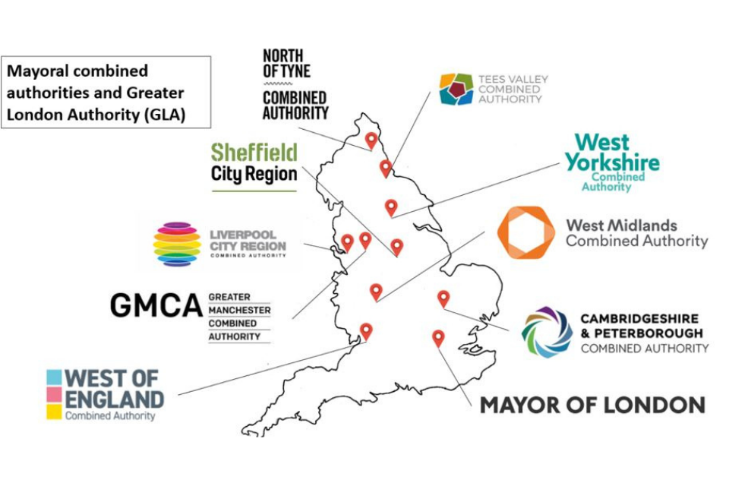A map of the mayoral combined authorities (Greater London is not a ‘combined authority’, but is included here for completeness).

The following devolved areas are responsible for administering their own funding.
Cambridge and Peterborough
Greater London
Greater Manchester
Liverpool City Region
North of Tyne Combined Authority
Tees Valley
West of England
West Midlands

Sheffield City Region (subject to legislation being in place) and West Yorkshire will become responsible for administering their own funding from 1 August 2021
Sheffield City Region
West Yorkshire

Updated: 4/6/21 (JB)

